CPD Certificate

Ear Mites - Otodectes Cynotis

“A Brief Overview”

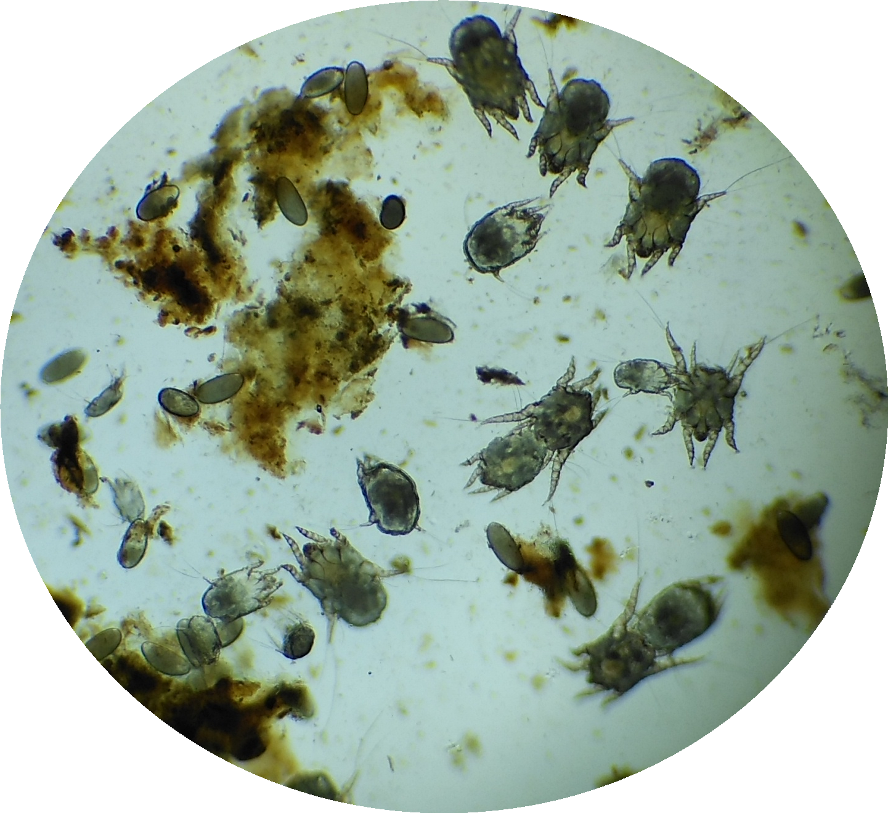
This certificate certifies that the person named below has successfully completed 1 hour of CPD training from the Dechra Website.

Name:

Date:

